April 9, 2010 - Justin Doo
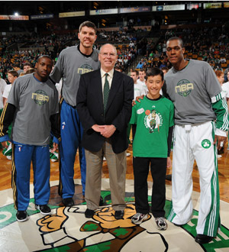
The Heroes Among Us award is a program of the Boston Celtics, presented by the Mass State Lottery.
At age seven, Justin Doo was diagnosed with Moya-Moya, a rare congenital brain disorder that causes "mini strokes" and affects just one in every two million people. With surgery as the only option, Justin endured an 8-hour operation to help increase blood flow to his brain. Though he will have this difficult and mysterious disease for the rest of his life, Justin has remained positive throughout the experience.
Justin has also become an avid fundraiser, participating in walks for Children's Hospital through his JUSTINcredibles team. He has also organized yard sales and carwashes and in total has raised nearly $80,000 for Moya-Moya research by the age of ten!!
For his inspirational journey and amazing impact at such a young age, please welcome tonight's Hero Among Us, Justin Doo!

